***International Investment Conference Croatia***  
Hotel Park *****, Split, Croatia, EU  
31st May and 1st June 2019



We are delighted to announce that we are going to bring the 1st International Investment Conference in Split, Croatia which will be held on 31st May and 1st June 2019.

The Conference (IICC) is envisaged as two-day event with particular focus on different ways of investment opportunities in Croatia and SEE region. Other international projects are also welcomed. Special focus will be on top quality projects. As projects could be in different stages of investment phases, different types of investors are invited. Investment management professionals could target their future business opportunity.

The purpose of the conference is to gather investors and projects representatives at one place and to make them network and find new opportunities for themselves as for their companies.

Conference objectives:

1. To get an insight into global investment trends
2. To promote investment opportunities for local and international investors
3. To present local and international projects
4. Networking
5. Promotion of life in Croatia – post conference events

IICC would like to bring the international experience in Croatia and the region. This conference is envisaged as a business meeting of investment professionals and project owners. The focus will also be on the knowledge transfer in the fields of strategy execution and legal framework for investments and investment insurance.

Who is it intended for:

* Financial institutions
* Investment funds
* VC/PE companies
* Private investors
* Consulting companies
* Project owners
* Projects representatives
* All the other interested parties

There is a limited number of seats so please reserve your place on time.

***Let your next business escape be in Croatia !***

**DAY 1 / 31st May 2019**

|  |  |  |
| --- | --- | --- |
| Times | Activity/Session | Location |
| 09:30 – 10:00 | Registration, Coffee & Networking | Hotel Park - Lobby |
| 10:00 – 10:15 | Welcome & Opening Remarks  *Formal welcome and introduction by official representatives (to be confirmed)* | Hotel Park – Grand Park Hall |
| 10:20 – 11:00 | Global investment trends   * *An overview of current global economic and investment trends* * *Global influence on the SEE region* * *Forcast for the region as a future market place* | Hotel Park – Grand Park Hall |
| 11:00 – 12:00 | Panel: What happens in Southeast Europe?   * *Spotlight on the region, investment opportunities, market potentials* * *Investment funds in the region* * *Tourism Industry and hotel investments* | Hotel Park – Grand Park Hall |
| 12:00 – 12:20 | Refreshments | Hotel Park – Lobby/Terrace |
| 12:20 – 12:40 | Asset Management in Hospitality, Real Estate and Tourism | Hotel Park – Grand Park Hall |
| 12:40 – 13:30 | Panel: What do investors look for   * *VC representative* * *Institutional representative* * *Private investors* | Hotel Park – Grand Park Hall |
| 13:30 – 14:30 | Lunch & Networking | Hotel Park - Restaurant |
| Afternoon Sessions | | |
| 14:30 – 14:50 | Investment opportunities in Croatia | Hotel Park – Grand Park Hall |
|  | * *Croatia as one of the best destinations for tourism investments – Financial Times* |  |
| 14:50 – 15:50 | Projects presentations and case studies:   * *Infrastructure* * *Tourism* * *Technology* | Hotel Park – Grand Park Hall |
| 15:50 – 16:10 | Legal framework for investments and investment insurance  *Performed by Mr.Časlav Žaja*  *Mr. Žaja is legal expert in the field of insurance and corporate law with extensive international experience* | Hotel Park – Grand Park Hall |
| 16:10 – 16:30 | Closing | Hotel Park – Grand Park Hall |
| 17:00 – 18:30 | Guided city tour | Diocletian’s Palace / old town of Split |
| 20:00 – 22:00 | Hotel terrace cocktail networking | Hotel Restaurant Terrace |

**DAY 2 / 1st June 2019**

|  |  |  |
| --- | --- | --- |
| Times | Activity/Session | Location |
| 09:00 – 09:30 | Coffee & Networking | Hotel Park – Grand Park Hall |
| 09:30 – 10:30 | Panel: Infrastructure and Investments | Hotel Park – Grand Park Hall |
| 10:30 – 11:00 | Digital transformation –   * *Are there any AI projects in the region?* | Hotel Park – Grand Park Hall |
| 11:00 – 11:20 | Refreshments |  |
| 11:20 – 12:30 | BONUS: **Strategy Execution**  *Performed by Mr. Jeroen De Flander*  *Mr. De Flander is one of the world’s most influential thinkers on strategy execution and a highly regarded keynote speaker.* | Hotel Park – Grand Park Hall |
| 12:30 – 12:50 |  |  |
| 12:50 – 13:00 | Closing conference | Hotel Park – Grand Park Hall |
| 13:00 – 15:00 | Networking event with lunch | Eco village near Split |

**FINAL AGENDA**  
Final agenda will be presented soon.

**We hope to see you in Split this year!**

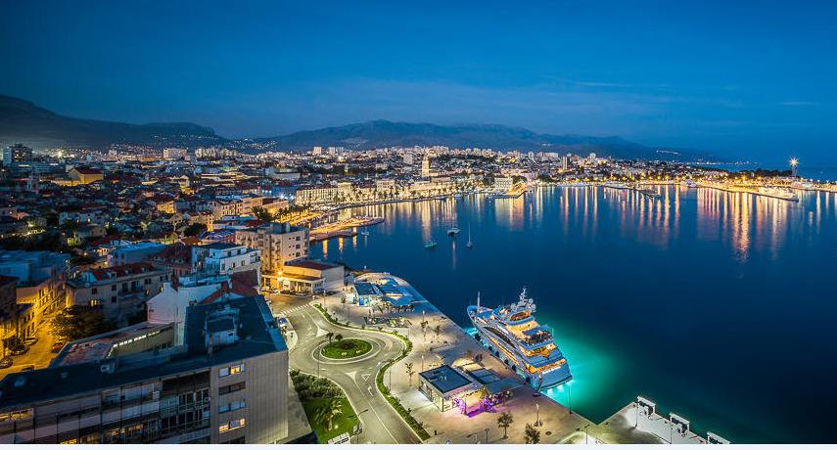

Contact us at:

[b-events@bomis.hr](mailto:b-events@bomis.hr)